**Lean Software development**

Lean product development is a process for building products faster with less waste.

Lean development forces the team to ruthlessly remove any activity that does not bring ultimate value to the product.

The goal of lean product development is to improve the overall throughput of the system, sustainably, in ways other than just simply throwing more money and resources into it.

Lean product developers are fixated on building products that customers find useful because knowing what their customers want helps teams eliminate waste

Lean development is a methodology that comes directly from Lean Manufacturing, created by Toyota, and applied to software development. This method offers a conceptual framework and follows values, principles and good development practices that can be applied to an Agile development approach.

Lean development forces the team to ruthlessly remove any activity that does not bring ultimate value to the product.

The goal of lean product development is to improve the overall throughput of the system, sustainably, in ways other than just simply throwing more money and resources into it.

**Principles**

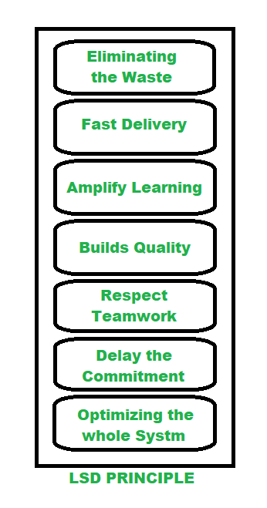

**Eliminating the Waste:** To identify and eliminate wastes e.g. unnecessary code, delay in processes, inefficient communication, the issue with quality, data duplication, more tasks in the log than completed, etc. regular meetings are held by Project Managers. Which allows team members to point out faults and suggest changes in the next turn.

**Fast Delivery:** Previously long time planning used to be the key success in business, but in the passage of time it is found that engineers spend too much time on building complex systems with unwanted features. So they came up with an MVP strategy which resulted in the building products quickly that included a little functionality and launch the product to market and see the reaction. Such an approach allows them to enhance the product on the basis of customer feedback.

**Amplify Learning:** Learning is improved through ample code reviewing, meeting that is cross-team applicable. It is also ensured that particular knowledge isn’t accumulated by one engineer who’s writing a particular piece of code so paired programming is used.

**Builds Quality**: LSD is all about prevent waste, keeping an eye on not sacrificing quality. Developers often apply test-driven programming to examine the code before it is written. The quality can also be gained to get constant feedback from team members and project managers.

**Respect Teamwork**: LSD focuses on empowering team members, rather than controlling them. Setting up a collaborative atmosphere, keep perfect balance when there are short deadlines and immense workload. This method becomes very much important when new members join a well-established team.

**Delay the Commitment:** In traditional project management it often happens when you make your application and it turns out to be completely unfit for the market. LSD method recognizes this threat and makes room for improvement by postponing irreversible decisions until all experiment is done. This methodology always constructs software as flexible, so the new knowledge is available and engineers can make improvements.

**Optimizing the whole system:** lean’s principle allows managers to break an issue into small constituent parts to optimize the team’s workflow, create unity among members, and inspire a sense of shared responsibility which results in enhancing the team performance.

**Key feature of LSD:**

* Focus on continuous improvement and waste elimination
* Iterative and collaborative approach
* Development of Minimum Viable Product (MVP)
* Customer involvement and feedback
* Flexible and adaptive approach
* Prioritization of essential functions and minimization of waste